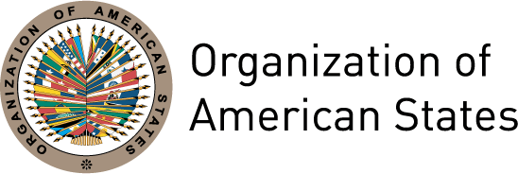
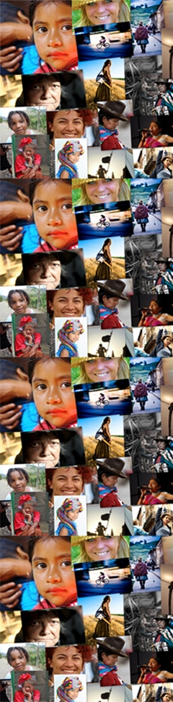

Briefing Note
A Rights-based and Gender Equality Approach to
Citizen Security in the Americas

The lack of citizen security in the Americas constitutes one of the principal threats to stability, democratic governance and sustainable human development. In Latin America and the Caribbean, homicides double the world average, and in some areas are five times that figure. A region that is home to only 8% of the world’s population also hosts 42% of murders and 66% of kidnappings.

Though the lack of citizen security is a problem that affects the whole population, women experience violence, dispossession, trafficking and other security threats in a different way than men (see Table 1). This difference is primarily a result of the social construction of gender roles and the relegation of women to the private sector. As stated by UNDP, “It is not simply a quantitative difference in, for example, the number of homicides of men or women, or who commits them.” Moreover, among women, gender differences intersect with differences in economic status, ethnicity, age, physical capacity, sexual orientation, gender identity and other factors that affect certain people’s vulnerability.

Table 1

Threats to the security of men, women, boys and girls
Men | Women | Boys | Girls
- Robbery  - Assault (simple or aggravated)  - Gang violence  - Homicide  - Rape and sexual torture  - Human trafficking and smuggling  - Homophobic or transphobic violence | - Domestic violence  - Sexual assault or harassment  - Rape and sexual torture  - Femicide  - “Honour” crimes  - Forced sterilization  - Human trafficking and smuggling  - Forced sexual exploitation  - Homophobic or transphobic violence | - Gang violence  - Child abuse  - Rape  - Incest  - Abandonment  - Human trafficking and smuggling  - Forced sexual exploitation | - Infanticide  - Child abuse  - Rape  - Incest  - Kidnapping  - Human trafficking and smuggling Forced sexual exploitation  - Child marriage
However, as Rainero states, “…it is possible to observe that both public debate on the issue of insecurity, and the public policies and actions designed to address it, are based on indicators that reduce violence to criminal typologies that tend to exclude the violence exercised specifically against women.”

Violence against women: A question of security
The countries of Latin America and the Caribbean have gradually adapted their national legislation to the international and inter-American legal framework on women’s rights, within which particular emphasis is placed on the Convention on the Elimination of all Forms of Discrimination against Women (CEDAW, 1979) and the Inter-American Convention to Prevent, Punish and Eradicate Violence against Women (Belém do Pará Convention, 1994). According to the OECD, Latin America and the Caribbean is the developing region that has made the most progress in the formal recognition of women’s rights – from the adoption of international and inter-American level commitments and the recognition of equality between women and men at the constitutional level, to the formulation of laws and public policies on women’s rights and gender equality.

Similarly, Latin America and the Caribbean is the region that has made the most progress in closing the gap between women and men in terms of education, labour force participation, civil, property and land rights and family codes, among other issues. However, these commitments and advances still have not translated into the adequate protection of women’s physical integrity and security, with physical and psychological violence highlights as particular concerns in Brazil, Guatemala, Haiti and Jamaica.

The fundamental paradox of violence against women is that we know that it is highly prevalent in various forms throughout the region, and that it negatively impacts women and men’s lives, human development and security. A growing body of case study research supports the general assertion that 1 in 3 women has, at some point in her life, experienced physical or sexual violence. However, there is still a significant dearth of specific knowledge of the incidence, causes, costs and consequences of violence against women.

Public/private: Deficiencies of the traditional approach to security

Bunch emphasizes that violence against women is part of the perpetuation of war, conflict and insecurity and the acceptance of violence as a normal and inevitable mechanism of conflict resolution. “The climate of impunity for violence against women that exists at the core of most societies – the notion that men and boys have that they can get away with it - feeds the culture of impunity towards violence more generally.”

The global change in the nature of conflict – from interstate and civil wars to local conflicts, political repression and organized crime – demand a change of focus in security policy that recognizes the threats inherent in poverty, HIV, racism, domestic violence, ethnic conflict, and population displacement, among other factors. However the same institutional weakness that allows the existence and growth of organized crime and the violence it implies also hinders the formulation of an adequate response to these new, or emerging, threats.
Though all human rights exist in both the private and public spheres, violence against women (in particular intra-family or domestic violence) in still considered by society to be a private problem that should be resolved between couple, as opposed to a threat to women’s security. This has meant in practice that the issue is not included in public policy on security, nor is it visible as part of the mandate of protection of the security sector in the majority of countries of the region.

The traditional approaches to national or public security clearly demarcate certain areas of insecurity and certain types of criminal behaviour – and as a result certain areas of responsibility and action. In general, these are limited to either external threats to national borders or ill-defined threats of “terrorism” or to crime and delinquency in the public sphere. These approaches limit both our understanding of violence as a social phenomenon and our ability to address it in an integral and effective way through legislation or public policy.

The emphasis placed on public spaces as sites of insecurity assume, implicitly or explicitly, that the home is a safe space or a refuge from the violence happening in the streets. For women, the reality is often the reverse, since they experience violence largely in their own homes, at the hands of intimate partners or other relatives or acquaintances.

Women, criminality and violence

Women are of course victims – as well as perpetrators – of crimes and violence in public spaces. However as victims and as perpetrators, insecurity also exists for women in the private sphere. In dividing our consideration of security to the public sphere, and women to the private sphere, we limit our understanding of the relationship between women, criminality and violence and we create significant gaps in public policy and attention to this issue.

In relegating women to the private sphere, the violence that is exercised by them also tends to be focused on the private sphere, often against children or older persons who are even more vulnerable. The role of women in violence within the public sphere has not been the subject of extensive study and is thus poorly understood. We know that women participate in delinquency, crime, gang activity and even in terrorism, but we have little idea of how this participation manifests itself.

In very general terms and based on isolated case studies, women represent between 10% and 25% of the members of gangs and other groups of the same nature, in which they fulfill three main roles: most often they are sexual companions of male members of the group; less often they serve as collaborators and links between the group and the outside world, and least commonly they are themselves criminals.

Women and citizen security

The greatest part of debate and literature on the issue of (citizen) security from a gender perspective has focused on the issue of safe cities. While taking into account the majority of women, this focus ignores a significantly under-research and under-serviced group of women in peri-urban and rural areas, where gender differences often meet with ethnic and economic differences to aggravate women’s insecurity to a variety of threats.

For women, the city can be a site of both challenge and opportunity. On the one hand, cities have allowed many women to break with traditional gender roles, enter the labour market, participate in civic and political actions and decision-making processes, and exercise a level of autonomy that may not have been possible in other contexts. On the other hand, cities are spaces of greater anonymity and danger where women may suffer more, and more varied, violence than in other contexts.

It is worth noting that women often lack the possibility to use cities – or urban spaces – in the same ways as men. “Just as women are under-represented in decision-making spaces and political power, the use of the streets and of public spaces, the collective image and the design of cities still respond to male domination. Urbanism and territorial planning still have not incorporated the diversity of subjects that inhabit cities or the different lived experiences of men and women…The differences in perception and experience of in/security in cities need to be prioritized.”

This differentiation of in/security on the basis of the rights and lived realities of women demands recognition and an integral response to violence against women as a security issue. In this sense, it is the citizen security approach that, on the one hand, allows us to see “security” as a state in which citizenship rights can be fully exercised and, on the other hand, gives the security sector the responsibility to address the violence and crime that happens in the private sphere.

Security: Who decides, who acts?

In addition to the invisibility and the lack of response to women’s in/security, it is clear that women are, for the most part, excluded from the discussion, formulation and implementation of security policies and programmes. For example:
- In the United States, women occupy between 12% and 14% of police posts. This figure reaches 18% in Jamaica, 10% in Venezuela and 18% in Canada.
- According to data from the United Nations’ Department of Peacekeeping Operations (DPKO, April 2011), of 14,669 police officials deployed to 17 peace missions, only 9.7% are women. Of 84, 713 military personnel deployed to 17 peace missions, only 2.5% are women.
- In Canada (2006), 12.8% of armed forces’ personnel were women. In the United States, this figure reached 10.5%.
- In Latin America, 19% of high-level positions in the justice sector are occupied by women (see Table 2).

Table 2
Percentage of women in the highest court or supreme court

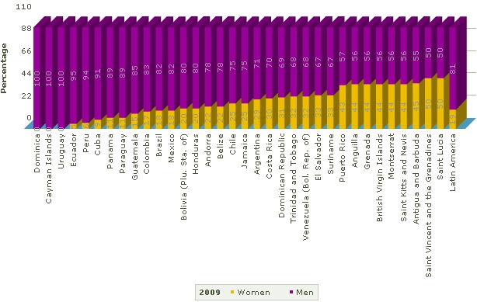

The lack of consideration of women’s security situation and Rights, on the one hand, and their absence from decision-making and action related to security, on the other hand, means that security policy in the majority of countries of the region ignores more than 50% of the population of these countries.

The integration of a rights-based and gender equality approach to the promotion and protection of security is essential to ensuring that women enjoy this security in a full and equal manner. The use of differential criteria in the analysis of security threats strengthens the capacity of the security sector to respond effectively to these threats, within a framework of human rights and the priorities and demands of different population groups.
Policy and action recommendations

Policy and action recommendations have been formulated, and endorsed, by governments, civil society groups, international organizations and other bodies, though the biggest challenge lies in their effective implementation. Specific commitments are spread over a number of different agreements, including the Belém do Pará Convention (1994), the Beijing Declaration and Platform for Action (1995), various resolutions of the United Nations Security Council on women, peace and security (1325, 1820, 1888, 1889, etc.), and the Consensus of Santo Domingo on Public Security (2009), among others. Below is a brief, and non-exclusive, summary of these recommendations:
- Incorporate differential criteria for all population groups in the analysis of existing and emerging threats in order to strengthen the response to these threats on the basis of the realities, rights and priorities of each group.
- Include more women in the security sector – from entry-level to high-level decision-making posts.
- Implement codes of conduct for security personnel – both internally (to regulate sexual harassment and other problems) and externally (to regulate interaction between security personnel and the public), and including private military and security companies.
- Establish accountability and reporting mechanisms to monitor and enforce compliance with agreed international, inter-American and national commitments on women’s rights and security.
- Create opportunities for education, training, employment and income-generation for young men and women as a viable alternative to criminality.
- Strengthen the State response to violence against women as a security threat through norms and protocols, in particular for the security sector and taking into account the impact that factors like race, ethnicity or sexual orientation may have on women’s interaction with security institutions.
- Strengthen the capacity of civil society groups, in particular women’s organization, to conduct integrated monitoring of women’s security situation and their relationship with the security sector, on the basis of agreed international, inter-American and national commitments to women’s human rights.
- Encourage young people to participate actively in political and decision-making processes and to demand transparency in these processes, particularly in relation to security.
- Design and implement information, awareness-raising and capacity-building campaigns on potential security threats, including violence against women, and how to prevent or avoid them.

Though no unified definition of citizen security exists, this briefing note prioritizes the importance of understanding security as a state where all people are able to fully exercise their human rights without fear that these rights may suddenly be lost or taken away. In accordance with the argument made by the OAS’ Inter-American Commission of Human Rights, “This group of rights includes the right to life, the right to physical integrity, the right to freedom, the right to due process and the right to the use and enjoyment of one’s property, without prejudice to other rights …” From: IACHR. Report on Citizen Security and Human Rights. Washington, DC: Organization of American States, 2009, p.6. http://www.cidh.oas.org/countryrep/Seguridad.eng/CitizenSecurity.Toc.htm
SMS. Public Security in the Americas: Challenges and Opportunities. Washington, DC: Organization of American States (Secretariat for Multi-dimensional Security), 2008, prologue. http://www.oas.org/dsp/documentos/Observatorio/FINAL.pdf
Carcedo, A. Cuadernos de Desarrollo Humano No.2: Seguridad Ciudadana de las Mujeres y Desarrollo Humano. Costa Rica: United Nations Development Program, 2006, p.7. http://www.pnud.or.cr/images/stories/downloads/pdf/Cuaderno02.pdf
Table adapted from: Denham, T. “Police Reform and Gender” in Bastick, M and y K. Valasek (eds.), Gender and Security Sector Reform Toolkit. Geneva: DCAF, OSCE/ODIHR, UN-INSTRAW, 2008, p.3. http://www.dcaf.ch/Publications/Publication-Detail?lng=en&id=47391
Rainero, L. et al. Herramientas para la promoción de ciudades seguras desde la perspectiva de género. Córdoba: CICSA, 2006, p. 7 http://www.redmujer.org.ar/pdf_publicaciones/art_17.pdf
OECD. Atlas of gender and development: How social norms affect gender equality in non-OECD countries. Paris: Organization for Economic Cooperation and Development, 2010, p. 92, http://www.oecd.org/document/50/0,3746,en_2649_33935_44810034_1_1_1_1,00.html
Ibid., p.93.
See for example: WHO. Multi-country Study on Women's Health and Domestic Violence against Women. Geneva: World Health Organization, 2003. http://www.who.int/gender/violence/who_multicountry_study/en/
Srinivasan, A. “Gender Violence as Insecurity: Research Trends in South Asia.” New Voices Series (no. 9), February 2011. Santiago de Chile: Global Consortium on Security Transformation. http://www.securitytransformation.org/images/publicaciones/197_New_Voices_Series_9_-_Gender_Violence_as_Insecurity.pdf
Bunch, C. “A Feminist Human Rights Lens on Human Security.” Rutgers University: Centre for Women’s Global Leadership, 2004, p.5. http://www.cwgl.rutgers.edu/globalcenter/charlotte/humansecurity.pdf
Ibid., p.5
Bunch, op. cit., p.2
World Bank. World Development Report 2011: Conflict, Security and Development. Washington, DC: World Bank, 2011. http://wdr2011.worldbank.org/fulltext
Lattu, E. “Physical violence committed by women: Preliminary thoughts.” Presented at the European Group for the Study of Deviance and Social Control "Critical Perspectives on Crime Prevention." Finland: University of Tampere, 2003.
For example:. Rodríguez, J.A. and J.S. León “Mujeres y pandillas.” in Maras y pandillas, comunidad y policía en Centroamérica: Hallazgos de un estudio integral. Costa Rica: Demoscopía S.A, 2007. http://www.scribd.com/doc/32651664/5/MUJERES-Y-PANDILLAS
Rainero, op. cit., p.7.
Citizenship rights are those civil, political, economic, social and cultural rights – human rights – that every democracy should guarantee and promote. UNDP and OAS. Our Democracy. Mexico: FCE, UNDP and OAS, 2010. http://www.nuestrademocracia.org/
“Lonsway, K. et al. “Equality Denied: The Status of Women in Policing, 2001.” Virginia: National Center for Women & Policing, 2002. http://www.womenandpolicing.org/Final_1999StatusReport.htm
Denham, op.cit., p.4
DPKO. Monthly Summary of Contributors of Military and Police Personnel (abril 2011). http://www.un.org/en/peacekeeping/resources/statistics/gender.shtml
Hendricks, C. & L. Hutton. “Defence Reform and Gender.” in DCAF, OSCE/ODIHR, UN-INSTRAW, 2008, op.cit., p.6. http://www.dcaf.ch/Publications/Publication-Detail?lng=en&id=47394
ECLAC. Gender Equality Observatory of Latin America and the Caribbean, http://www.cepal.org/oig/adecisiones/default.asp?idioma=IN (consulted on 3/06/2011)
Fairness, comprehensiveness, local focus, public participation and transparency are some of the 18 principles that the OAS General Secretariat/Department of Multi-Dimensional Security argues should be part of any public security policy SMS, op. cit. p. 67-69.
The security sector or system is understood as the totality of all state institutions and other entities that play a role in ensuring the security of the state and its inhabitants. These include: Key security actors (national, regional, and international armed forces, police, gendarmeries, paramilitary forces, presidential guards, security and intelligence services, coast or border guards, customs officials, and local or reserve security units); Security management or oversight bodies (the parliament or other legislative body, legislative committees, the executive body, and ministries related to defense and domestic and foreign affairs, national security advisory bodies, traditional and/or community authorities, financial management bodies, and civil society actors, including the news media); Institutions of justice and the rule of law (ministries of justice, prisons, criminal investigation and prosecution services, the judicial sector (courts and tribunals), law enforcement services, traditional and/or community justice systems, human rights commissions, and ombudsmen); Non-state security forces (liberation armies, guerrillas, private security guards, private or military security companies, political party militias); and Civil society (professional associations, the news media, research institutions, polling organizations, religious organizations, nongovernmental organizations, and community groups). From: Valasek, K. "Security Reform and Gender." in DCAF, OSCE/ODIHR, UN-INSTRAW, 2008, op.cit.. http://www.dcaf.ch/Publications/Publication-Detail?lng=en&id=47331

